CR-V Interior Color 2009

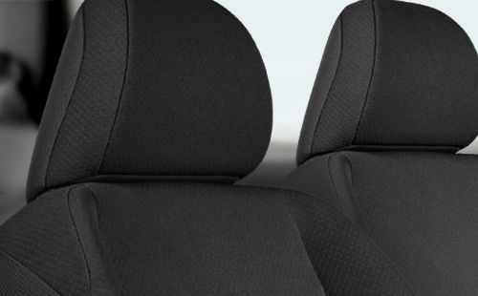
CR-V LX Black Fabric.
View all color combinations
  LX |   LX | 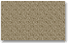  LX |  | 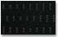  EX | 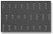  EX | 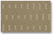  EX |  |   EX-L |   EX-L | 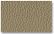  EX-L

