Civic GX Sedan NGV Interior Style & Color 2009
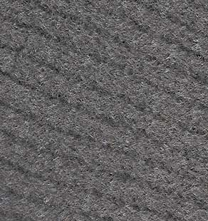
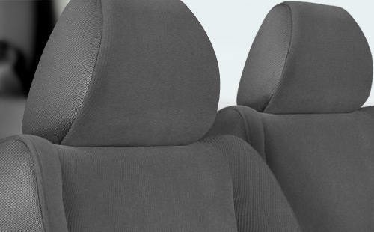
Civic GX Gray Fabric.
View all color combinations
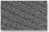  GX |   GX

