Civic Hybrid Interior Style & Color Chart 2009
Exterior
Interior
Color Chart

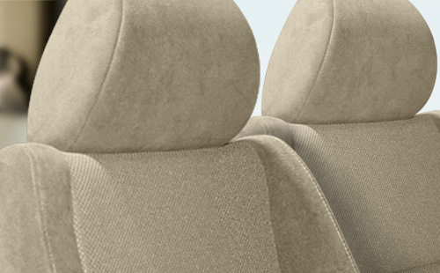
Civic Hybrid Beige Fabric.
View all color combinations
  Hybrid |   Hybrid |  | 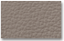  Hybrid with Leather |   Hybrid with Leather

