Civic Si Coupe Interior Style & Color 2009

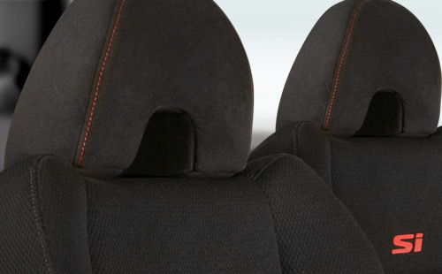
Civic Si Coupe Black Fabric.
View all color combinations

Si

