Civic Si Sedan Interior Style & Color 2009

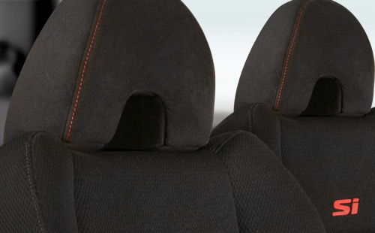
Civic Si Sedan Black Fabric.
View all color combinations

Si

