Element Interior Color Chart 2009
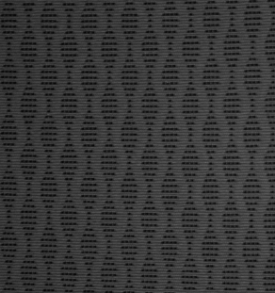
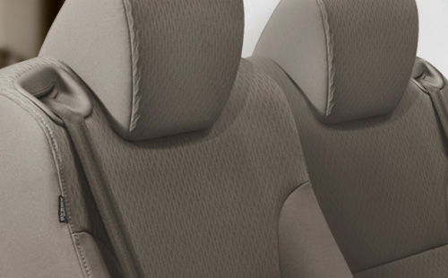
Element LX Gray Fabric.
View all color combinations
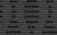  LX | 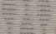  LX |  | EX | EX

