Element SC Interior Color 2009

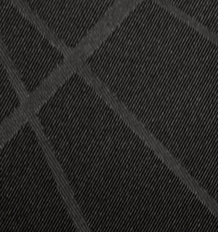
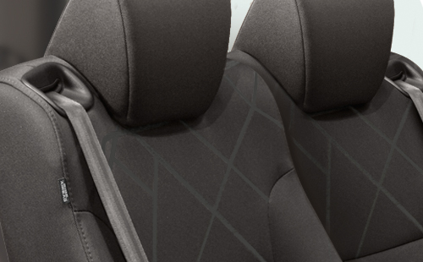
Element SC Titanium/Black Fabric.
View all color combinations
  SC |   SC

