Odyssey Interior Style and Color Chart 2009

Interior
Color Chart
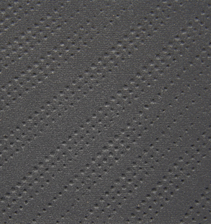

Odyssey LX Gray Fabric.
View all color combinations
  LX |   LX |  |   EX |   EX |   EX |  |   EX-L |   EX-L |   EX-L
  Touring |   Touring | Touring | Touring

