Pilot Color Chart 2009
 | LX | EX | EX-L | Touring
  Bali Blue Pearl
  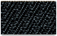
  Blue Fabric
  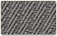
  Gray Fabric
  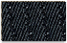
  Blue Fabric
  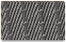
  Gray Fabric
  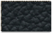
  Blue Leather
  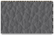
  Gray Leather
  Blue Leather
  Gray Leather
  Billet Silver Metallic
  Blue Fabric
  Gray Fabric
  Blue Fabric
  Gray Fabric
  Blue Leather
  Gray Leather
  Blue Leather
  Gray Leather
  Dark Cherry Pearl
  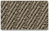
  Beige Fabric
  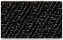
  Black Fabric
  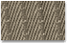
  Beige Fabric
  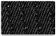
  Black Fabric
  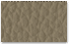
  Beige Leather
  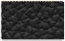
  Black Leather
  Beige Leather
  Black Leather
  Formal Black
  Gray Fabric
  Gray Fabric
  Gray Leather
  Black Leather
  Gray Leather
  Mocha Metallic
  Beige Fabric
  Beige Fabric
  Beige Leather
  Beige Leather
  Nimbus Gray Metallic
  Beige Fabric
  Beige Fabric
  Beige Leather
  Beige Leather
  Sterling Gray Metallic
  Black Fabric
  Gray Fabric
  Black Fabric
  Gray Fabric
  Black Leather
  Gray Leather
  Black Leather
  Gray Leather
  Taffeta White
  Blue Fabric
  Gray Fabric
  Blue Fabric
  Gray Fabric
  Blue Leather
  Gray Leather
  Blue Leather
  Gray Leather

