Pilot Interior Style & Color Chart 2009

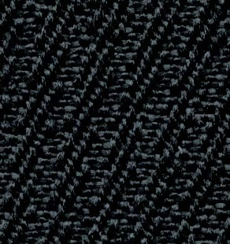
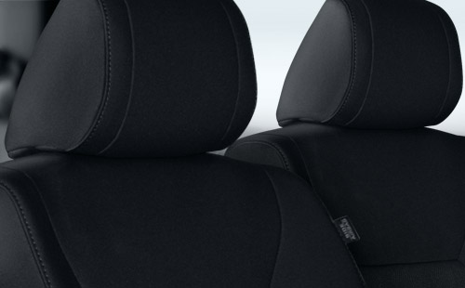
Pilot LX Blue Fabric.
View all color combinations
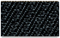  LX | 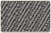  LX | 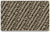  LX | 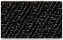  LX |  | 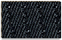  EX | 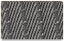  EX | 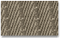  EX | 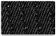  EX
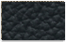  EX-L | 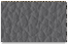  EX-L | 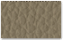  EX-L | 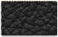  EX-L |  | Touring | Touring | Touring | Touring

