Ridgeline Color Chart 2009

 | RT | RTS | RTL
  Bali Blue Pearl
  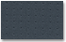
  Gray Fabric
  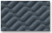
  Gray Fabric
  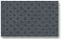
  Gray Leather
  Billet Silver Metallic
  Gray Fabric
  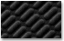
  Black Fabric
  Gray Fabric
  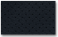
  Black Leather
  Gray Leather
  Dark Cherry Pearl
  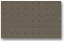
  Beige Fabric
  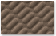
  Beige Fabric
  Black Fabric
  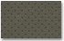
  Beige Leather
  Black Leather
  Mocha Metallic
  Beige Fabric
  Black Fabric
  Beige Leather
  Black Leather
  Nighthawk Black Pearl
  Gray Fabric
  Beige Fabric
  Black Fabric
  Beige Leather
  Black Leather
  Sterling Gray Metallic
  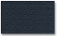
  Black Fabric
  Black Fabric
  Gray Fabric
  Black Leather
  Gray Leather
  White
  Beige Fabric
  Gray Fabric
  Beige Fabric
  Gray Fabric
  Beige Leather
  Gray Leather

