Ridgeline Interior Style & Color Chart 2009

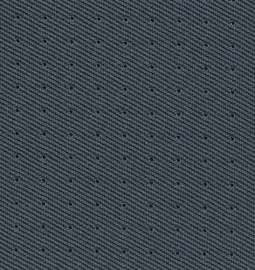
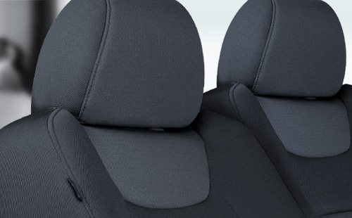
Ridgeline RT Gray Fabric.
View all color combinations
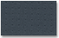  RT | 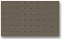  RT | 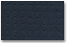  RT |  | 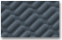  RTS | 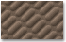  RTS | 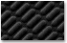  RTS |  | 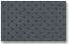  RTL | 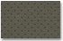  RTL | 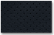  RTL

